

**ATC IT Production Release Notes Documentation**

|  |  |
| --- | --- |
| **PCR #:** | CHG0057578 |
| **Release Date:** | JUN-2023 |
| **Author(s):** | Shrey Singh Bisht |
| **Release Name:** | Ieng-ebs-api |
| **System** | Mulesoft Cloud |
| **Application SVN** | <http://svn.americantower.com:8080/atc/repos/svn/store1/Integrations/trunk/ieng-ebs-api> |
| **SVN Revision(UAT)** | HEAD |

|  |
| --- |
| **UAT Release** |

**Deployment Steps:**

**Backup:** Take the back up of existing JAR and runtime properties

**Document URL:**

UAT (Only) Deployment – DevOps – Jenkins

URL (Jenkins): <http://us1jen1.americantower.com:8090/view/UAT/>

**Jenkins Deployment:**

1. Create a new pipeline if not exist already.
2. Enter the name as **ieng-ebs-api-uat** and make a same copy as the Jenkins pipeline **ieng-ebs-api-qc.**
3. Provide the password for Jenkins parameter XXATC_PASSWORD of user XXEXT if required.
4. Check Cloudhub for successful deployment.
5. Health Check using the link: https://<domain/api/health>

and response should similar as below :

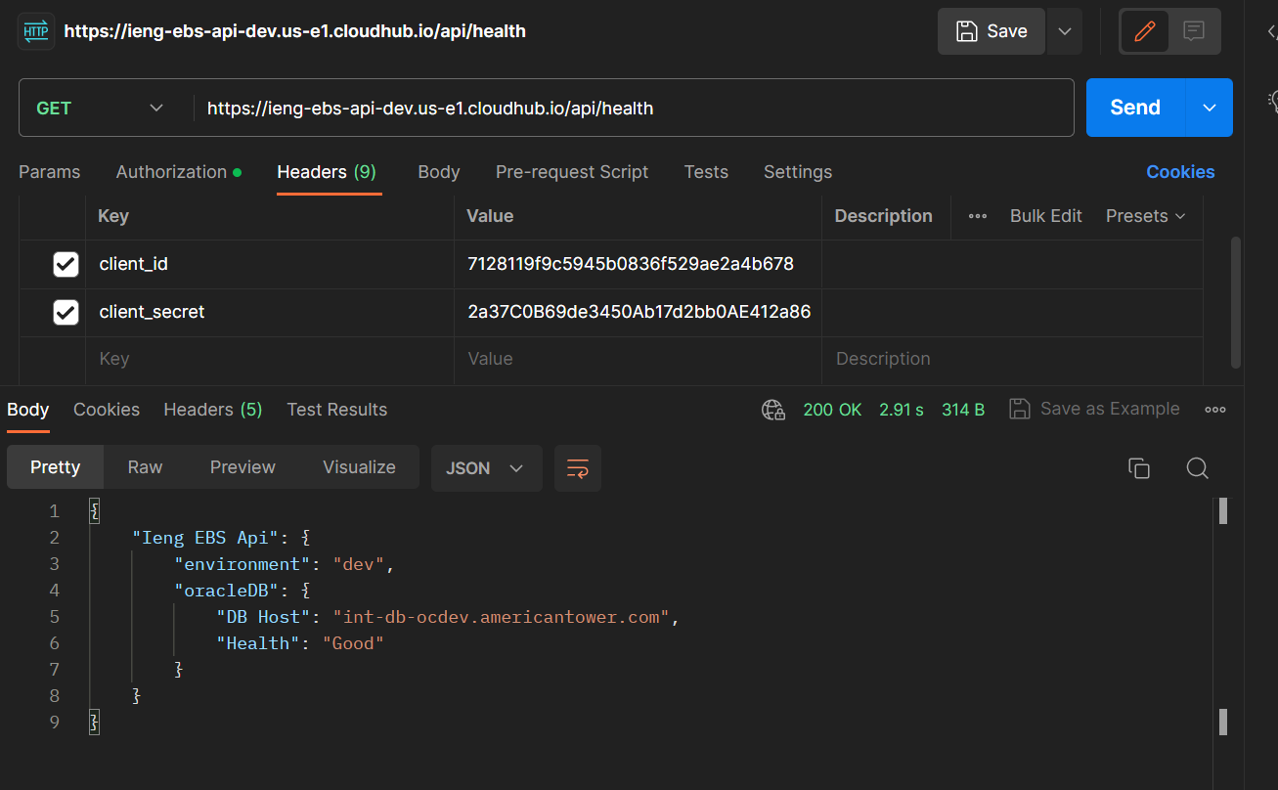

|  |
| --- |
| **Production Release** |

**Deployment Steps:**

**Backup:** Take the back up of existing JAR and run time properties

PROD (Only) Deployment – DevOps – Jenkins

URL (Jenkins): <http://us1jen1.americantower.com:8090/view/PROD/>

**Jenkins Deployment:**

1. Create a new pipeline if not already exist.
2. Enter the name as **ieng-ebs-api** and make a same copy as the Jenkins pipeline **ieng-ebs-api-uat.**
3. Provide the password for Jenkins parameter XXATC_PASSWORD of user XXEXT if required.
4. Use the excel sheet (mentioned in prerequisite), for the parameters to be configured.
5. Check Cloudhub for successful deployment.
6. Health Check using the link: https://<domain/api/health>

and response should similar as below :

